Section: Non Verbal Reasoning - Figures

Image : 1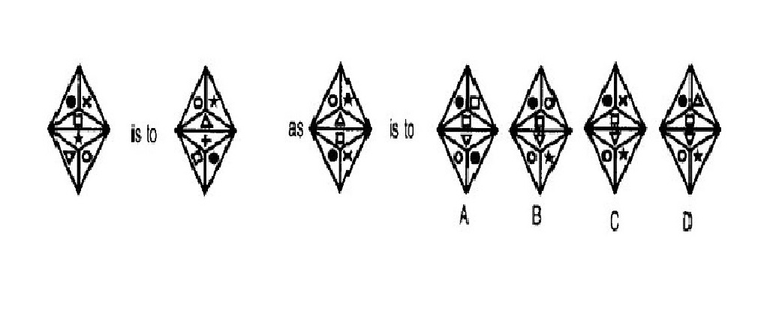Please refer Image 1 for the next question
Choose the correct option.

Q.1

A: A | B: B | C: C | D: D | E: E
Image : 2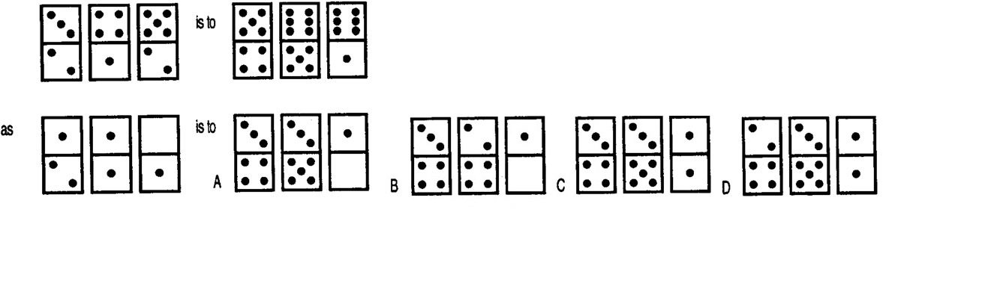Please refer Image 2 for the next question
Choose the correct option.

Q.2

A: A | B: B | C: C | D: D | E: E
Image : 3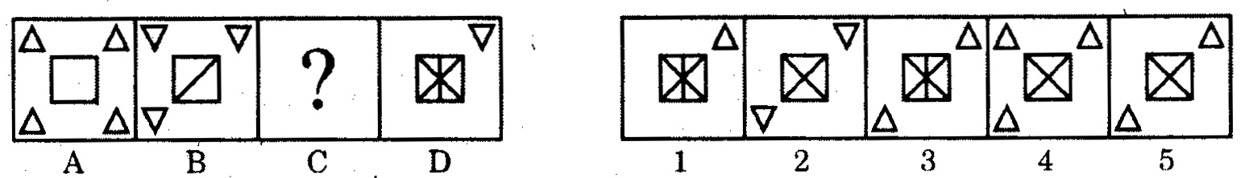Please refer Image 3 for the next question
Directions : In each of the following questions, there is a set of four figures labelled A, B, C and D called the Problem Set followed by a set of five other figures labelled 1, 2, 3, 4, and 5 called Answer Set. Figure (C) contains a question mark. Select a suitable figure from the Answer set which will substitute this question mark so that a series is formed by the figures A, B, C, and D taken in order. The number of the selected figure is the answer.

Q.3

A: 1 | B: 2 | C: 3 | D: 4 | E: 5
Image : 4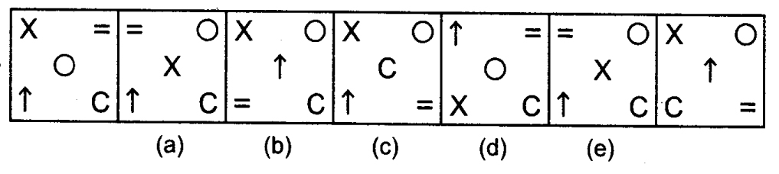Please refer Image 4 for the next question
Directions : In the following question, a series begins with unmarked figure on the extreme left. One and only one of the five marked figure does not fit into the series. The two unmarked figures, one each of the extreme left and extreme right fit into the series. You have to take as many aspects into account as possible of the figure in the series and find out the one and only one of the five marked figures which does not fit into the series. The number of that figure is your answer. Choose the correct answer.

Q.4

A: A | B: B | C: C | D: D | E: E
Image : 5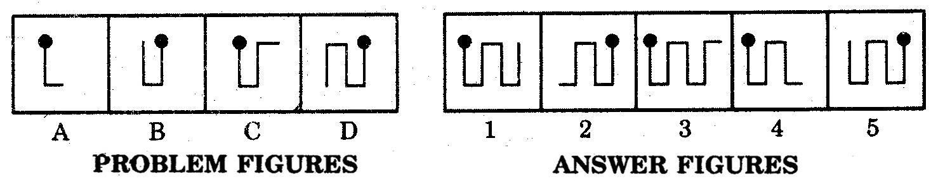Please refer Image 5 for the next question
Directions : Select a figure from the Answer set (figures 1,2,3,4,5) which would continue the series indicated by the four figures of the Problem Set (figures A,B,C,D)

Q.5

A: 1 | B: 2 | C: 3 | D: 4 | E: 5

